**SAMPLE PHP PROTOTYPE October 25, 2020 SUNDAY**

**SELECT * FROM php.requestor_records;**

**ALTER TABLE php.`requestor_records`**

**MODIFY `recordNumber` int NOT NULL AUTO_INCREMENT, AUTO_INCREMENT=1;**

**COMMIT;**

**INSERT INTO `php`.`requestor_records` (`recordNumber`, `sapId`, `SPOCName`, `SPOCMailId`, `contactNumber`) VALUES ('2', '51711223', 'Abcd abcd', 'abcd@hcl.com', '1234567891');**

**UPDATE `php`.`requestor_records` SET `contactNumber` = '7358622498' WHERE (`recordNumber` = '1');**

**UPDATE `php`.`requestor_records` SET `recordNumber` = '1' WHERE (`recordNumber` = '0');**

**ALTER TABLE `php`.`requestor_records`**

**ADD COLUMN `recordNumber` INT(11) NOT NULL FIRST,**

**DROP PRIMARY KEY,**

**ADD PRIMARY KEY (`recordNumber`);**

**;**

**INSERT INTO `php`.`requestor_records` (`sapId`, `SPOCName`, `SPOCMailId`, `contactNumber`) VALUES ('51722354', 'G Sunil Kumar', 'sunilkumarg@hcl.com', '7358622498');**

**CREATE TABLE php.`requestor_records` (**

**`sapId` int NOT NULL,**

**`SPOCName` text NOT NULL,**

**`SPOCMailId` text NOT NULL,**

**`contactNumber` int NOT NULL**

**) ENGINE=MyISAM DEFAULT CHARSET=latin1;**

**ALTER TABLE php.`requestor_records`**

**ADD PRIMARY KEY (`sapId`);**

**Sample Php Table creation for Php Form: ‘October 25, 2020 Sunday’**

SELECT * FROM php.table_form;

CREATE TABLE php.`table_form` (

`id` int NOT NULL,

`dbfield1` text NOT NULL,

`dbfield2` text NOT NULL,

`dbfield3` text NOT NULL,

`dbfield4` text NOT NULL

) ENGINE=MyISAM DEFAULT CHARSET=latin1;

ALTER TABLE php.`table_form`

ADD PRIMARY KEY (`id`);

AUTO_INCREMENT of table `table_form:

ALTER TABLE php.`table_form`

MODIFY `id` int NOT NULL AUTO_INCREMENT, AUTO_INCREMENT=1;

COMMIT;

INSERT INTO `php`.`table_form` (`id`, `dbfield1`, `dbfield2`, `dbfield3`, `dbfield4`) VALUES ('1', '1', '1', '1', '1');

INSERT INTO `php`.`table_form` (`id`, `dbfield1`, `dbfield2`, `dbfield3`, `dbfield4`) VALUES ('2', '2', '2', '2', '2');

INSERT INTO `php`.`table_form` (`id`, `dbfield1`, `dbfield2`, `dbfield3`, `dbfield4`) VALUES ('3', '3', '3', '3', '3');

Updating port number from ‘3306’ to ‘3307’ in ‘XAMPP’ by clicking ‘Config’ as seen below:

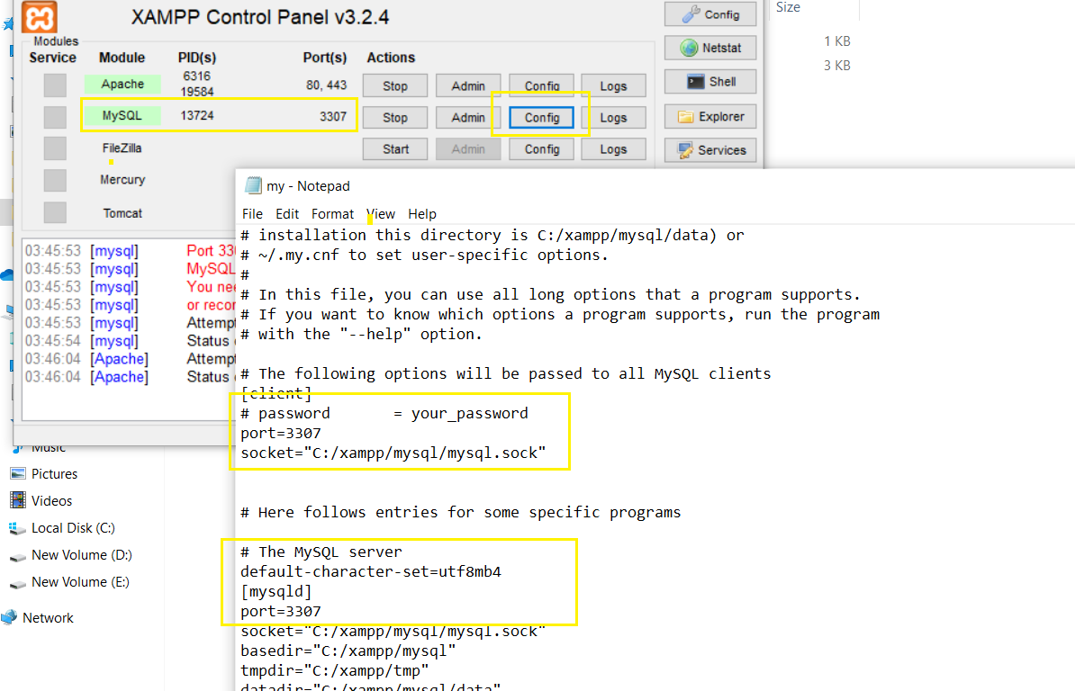

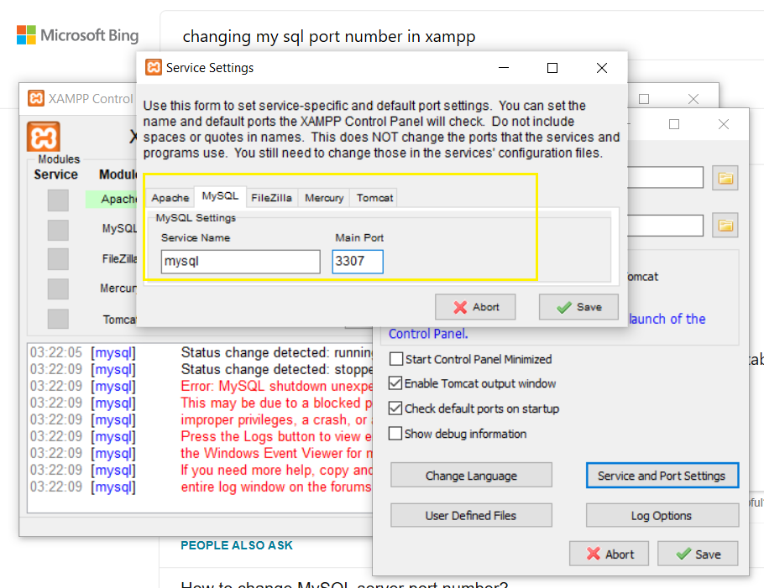

Set of H2 Queries to Create Table, Insert record into table, update records in the table and delete records in a table:

1. DROP TABLE IF EXISTS TEST;

2. CREATE TABLE TEST(ID INT PRIMARY KEY, NAME VARCHAR(255));

3. INSERT INTO TEST VALUES(1, 'Automation R 1');

4. INSERT INTO TEST VALUES(2, 'Automation R 2');

5. INSERT INTO TEST VALUES(3, 'Automation R 3');

6. UPDATE TEST SET NAME='Updated A R 1' WHERE ID=1;

7. SELECT * FROM TEST ORDER BY ID;

8. DELETE FROM TEST WHERE ID=3;

INSERT INTO TEST VALUES (1, 'Automation R 1');

INSERT INTO php.users VALUES('User 1', 'abcd1@gmail.com', '1234567891');

INSERT INTO php.users VALUES('User 2', 'abcd2@gmail.com', '1234567892');

INSERT INTO php.users VALUES('User 3', 'abcd3@gmail.com', '1234567893');

INSERT INTO php.users VALUES('User 4', 'abcd4@gmail.com', '1234567894');

CREATE TABLE `php`.`users` (

`name` VARCHAR(255) NOT NULL,

`email` VARCHAR(255) NOT NULL,

`mobile` VARCHAR(255) NOT NULL,

PRIMARY KEY (`name`));

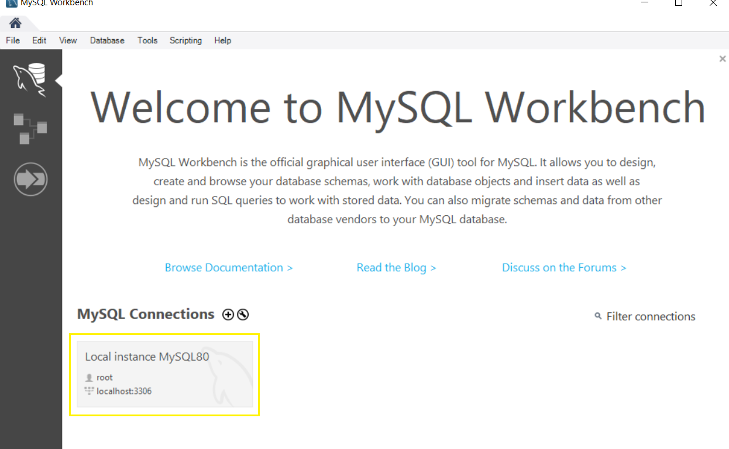

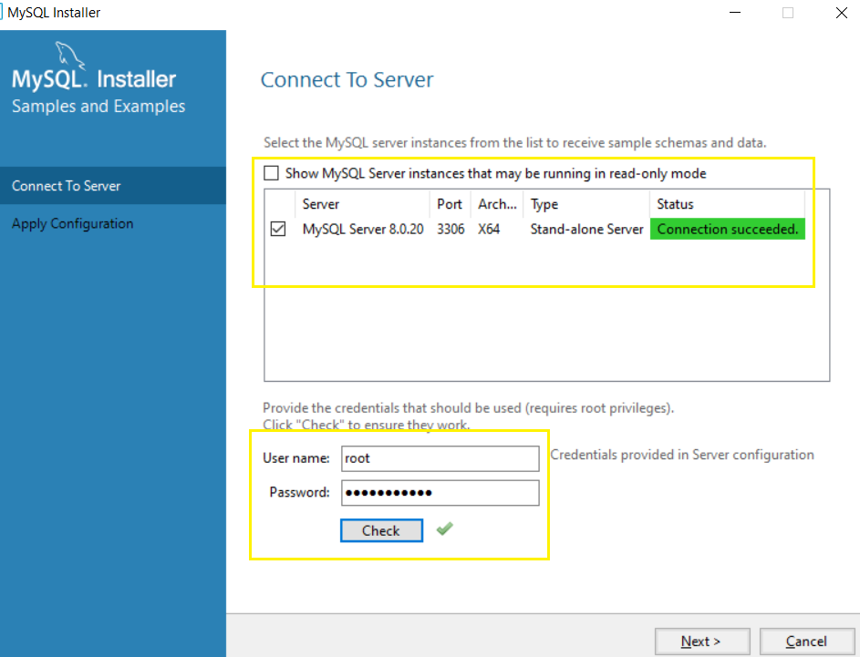

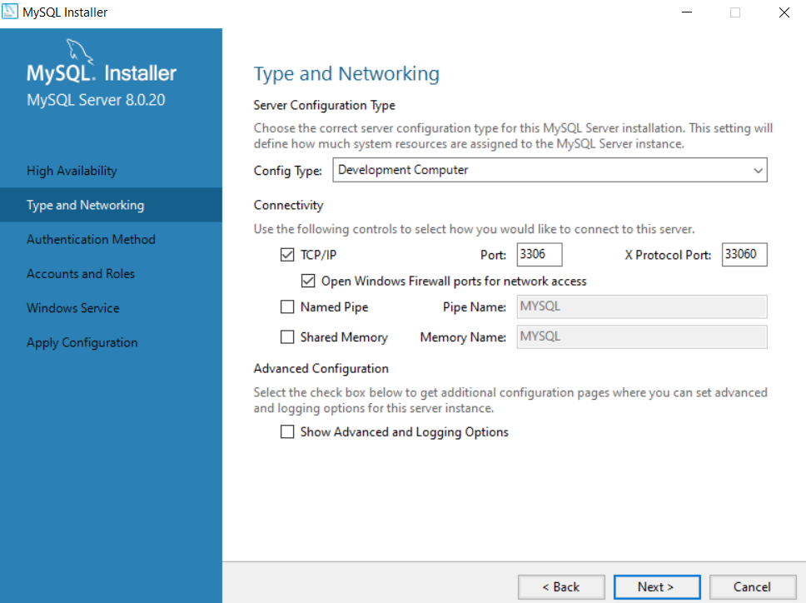

**References:**

1. Resolve error using undefined ROOT : <https://stackoverflow.com/questions/31712354/error-use-of-undefined-constant-root-assumed-root>
2. Personal Home Page tools PHP history : <https://en.wikipedia.org/wiki/PHP>
3. Saving a Php file in notepad without .txt in the end: <https://www.registerednursern.com/saving-a-php-file-in-notepad-without-txt-extension-save-as-php/>
4. CRUD Operations using Php: <https://github.com/taniarascia/pdo/tree/feba19a43e63c617c95a1f6e68825f6e3086336>c
5. CRUD operations using Php: https://www.taniarascia.com/create-a-simple-database-app-connecting-to-mysql-with-php/
6. Including another Php file in current php file: <https://www.youtube.com/watch?v=6m4PAMTC7Gg>
7. Resolving ‘Php MySQL’ connection issues: https://stackoverflow.com/questions/2218877/php-mysql-connection-failed#:~:text=Here%20are%20the%20troubleshooting%20steps,on%20port%203306%3A%20connection%20failed%22
8. Sample Php file : <https://www.javatpoint.com/run-php-code-in-xampp>
9. How to run the PhP Program: <https://www.youtube.com/watch?v=tlfVuqTQvx8>
10. How to create data base, table and table records in My SQL: <https://www.youtube.com/watch?v=wTrP7R0jYtQ>
11. Creating data base, table and table records in My SQL: <https://www.hightechnology.in/create-database-table-in-mysql/>